📘 SalesMetrics CRM
Developer & Admin Documentation
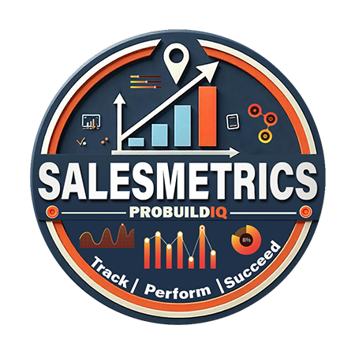
1. Overview
SalesMetrics CRM is a custom-built web application designed for the Sales Team to track AR activity, manage sales tasks, plan customer visits, monitor performance, and improve daily productivity.

2. Technology Stack
- Backend: ASP.NET Core 9 (C#), Entity Framework Core
- Frontend: Razor Views, Bootstrap, DataTables, Flatpickr, SweetAlert2
- Database: SQL Server 2019
- Hosting: IIS on Windows Server 2022
- Authentication: ERP-validated login plus role-based internal access (Admin, Sales Admin, Sales)

3. User Roles
Role Permissions
- Admin Full access to all users, tasks, and property data
- Sales Admin Access to sales data at location, assign tasks
- Sales Rep See their own tasks, properties, AR, orders

4. Core Features
✅ Dashboard
- Personalized greeting (Good Morning / Afternoon / Evening)
- Sales KPIs: Total AR, Due Amount, Invoice Counts
- Weekly Work Orders Chart
- AR Aging Summary
- Top Delinquent Customers
- Daily Task Overview with inline task editing
- Sales Rankings (Top 5 MTD & YTD reps)
✅ Tasks Management
- Task creation modal with role-based assignment logic
- Full task lifecycle (Create, Edit, Complete, Cancel)
- Modal-based task creation and Kanban View
- Inline Status updates on the Dashboard and Task pages
- Google Calendar Event creation for site visits or QCs
- Google Task creation for personal action items
✅ Work Orders
- Orders displayed by delivery date
- Ability to create tasks directly from a work order
- Click into full order details and property view
✅ Properties Management
- Assigned ERP properties (with dynamic location-based access)
- Imported Yardi Matrix properties
- Task creation directly from property records
✅ Customer Details
- View full sales history and AR balance for a property
- Monthly sales graph (last 12 months)
- Completed and Pending orders statistics
✅ Yardi Properties
- Import Excel data
- View and manage properties
- Create follow-up tasks tied to imported properties
5. Integrations
- Google Calendar API:
Adds an Event when a Site Visit or QC task is created
- Google Tasks API:
Adds a personal Task in Gmail; two-way sync enhancements in progress
- ERP Database (CompUFloorLA):
Live data connection for AR monitoring, sales performance, property records

6. Deployment
- Published as a framework-dependent win-x64 ASP.NET Core app
- IIS hosted with proper app pool (No Managed Code)
- Daily app pool recycles at 2 AM
- HTTPS enforced via redirect or URL Rewrite
- Google secrets secured via appsettings and HTTPS callback

7. Work in Progress
- Two-way sync with Google Tasks
- Enhanced AR Follow-Up Module (create follow-ups directly from AR aging list)
- Reporting and Export functionality for Admins
- Push notification or email integration (planned)

8. Admin & Troubleshooting
- Use IIS logs or stdoutLogEnabled for debugging crashes
- Task logs and sync status shown via TempData alerts
- SQL connection strings handled via office selection at login
- Admins can see all tasks and assign on behalf of users

9. Known Issues and Future Enhancements
- Google Tasks API still limited on update reflection
- Expand Daily Task Section to show overdue tasks separately
- Improve mobile responsiveness (low priority)

